POC on the Deep learning approaches to identify order status in a complex supply chain

Abstract:-

The integration of DL and ML for the prediction of the Late delivery risk in the supply chain (SC) domain can help in identifying whether any product will be delivered late due to any unforeseen reason in the complex supply chain system. In this case study we have experimented with different ML and DL models for the classification of late orders and in orders. We have used the DL models like Simple LSTM , Simple BiLSTM , Deeper BiLSTM , 1D-CNN and TCN-1DSPCNN models for feature extraction and then applied different ML algorithms for the classification which gives better accuracy.And then we have used Five-folding cross validation to check whether our models are over fitted or not. With this approach we have gained better results overall.

Introduction:-

The supply chain is defined as the communication between the supplier and the consumer which includes many subprocesses like product development, operation, distribution, marketing, customer service, and finance. And finally the most important part is order delivery. In some situations the orders are delivered on time and some orders are delivered late .In those late delivered orders some orders are getting damaged and some are not even delivered properly. So by using this integration of DL and ML approach in the prediction of the late delivery will reduce the risk in the supply chain and can have a chance to overcome order delivery problems and also helpe in minimising overall Supply chain cost.



Fig: Supply chain Management Flow

In this research we have used the Deep learning approaches for Feature extraction and then combined them with machine learning algorithms which builds a very strong approach for solving this type of problems.
In previous Research papers they tried to solve this problem by using different models and approaches like by using Machine Learning , Network based approaches, Deep learning , Statistical approaches , AI and Machine Learning based approaches .
Based on those research papers in this research we are trying to improve the accuracy and performance of the model on the real time data.
After pre-processing stage we have captured two sets of most salient features and then followed by feature extraction by Deep Learning approaches.
Feature Extraction through the Deep Learning models like LSTM,BiLSTM, 1D CNN , TCN-1DSPCNN will help in effectively capturing extracted features through the layered approaches.
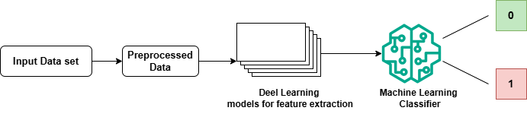
Fig: Basic Flow of the Model

Then that extracted features are passed to the Machine Learning algorithms like softmax , Random Forest , SVM, Decision trees , Random trees , MLP and KNN.
After the classification we have used Five-fold cross validation to know whether the model is overfitted or not. And then the model performance is evaluated by the classification evaluation metrics and then the results are visualized by using ROC curve , confusion matrix, loss function curves.

Methodology:-

To overcome the Late delivery risk in the supply chain we have used various deep learning (DL) and machine learning (ML) approaches to predict whether an order will be delivered in-time or late.
The basic methodology involves several steps from Data collection to the evaluation of the model.
The first step is Dataset importing , here we are importing the data set “DataCo SMART SUPPLY CHAIN FOR BIG DATA ANALYSIS ” from a publicly available source like Kaggle.
Then next we are doing preprocessing on the data like selecting important features , here we have used two sets of important features in our experiments . based on the two main criterias.

The first criteria is selecting the Features that are more related to Order Status.And the second criteria is choosing the columns that must contribute to an increase in the performance of Machine Learning (ML) and Deep Learning (DL) Methodologies. And then cleaning the data, encoding the data, transforming the data and finally splitting the data into X and y and then converting the data into our required form.
After preprocessing the data we are now applying the Feature extraction on the data with Deep Learning Approaches like simple LSTM, simple BiLSTM ,Deeper BiLSTM , 1D-CNN , TCN-1DSPCNN on the data.
Then we are passing the extracted features to the Machine Learning Classifiers and Deep Learning layers for the Classification of the Ladels like ”0” and “1” which “0” means in-time order and “1” means late order . Machine Learning algorithms like softmax(logistic regression), Random Forest ,Support vector machine ,KNN , Random Trees ,Decision Trees and MLP for the classification purpose.
We have used the Five-fold cross validation to check whether the model is overfitted or not. In Five-fold Cross validation the data is splitted into 5 parts and 4 parts are used for training and 5th part is used for evaluation purposes and this process is repeated for 5 times. So from this we check and overcome the overfitting problem in the models.
After classification we have used classification evaluation metrics to evaluate the performance of the models. Here we have taken TP,TN,FP,FN,Accuracy, precision , f1-score, Recall , Kappa statistics ..etc for evaluation of the model .And we have used
ROC curve, Loss function curve and confusion matrices for visualization.

Pseudo code:-

Step-1: Import the packages needed for building the models.
Pandas,numpy - Data Handling and math operation.
Train_test_split - Split data.
LabelEncoder , MinMaxSxaler - Preprocessing.
LogisticRegression,RF,SVC,KNN,DecisionTrees,MLP-ML Models.
Accuracy_score ,confusion_matrix , f1_score ,roc-Model evaluation.
LSTM, Dense , Bidirectional - Deep Learning.
Matplotlib , seaborn - Visualization.
Step-2: Load the dataset “ DataCo SMART SUPPLY CHAIN FOR BIG DATA ANALYSIS “ by using the numpy package
Step-3: Preprocessing of the data start.
Step-3.1: Selecting important features. Based on these two most important criteria we have taken the two subsets of important features for our research.
The first criteria is Selecting the Features that are more rellated to Order Status. And the second criteria is choosing the columns that must contribute to an increase in the performance of Machine Learining (ML) and Deep Learning (DL) Methodologies.

Step-3.2: Handling missing values.
Step-3.3: Handling the duplicates.
Step-3.4: LabelEncoding of the categorical values.
Step-3.5: Data Splitting X and y.
X → Features
y → Target
Step-3.6: Converting the X in 3 dimensional format as we are using the layer models.
Step-4: Feature extraction by using different Deep Learning Models.
Deep Learning models like :
Simple LSTM - 5 Layers.
Simple BiLSTM - 5 Layers.
Deeper BiLSTM - 7 Layers.
1D-CNN - 12 Layers
TCN-1DSPCNN - 44 Layers
Step-5: Then extracted features are stored in X_features and the target is stored in y.
Step-6: Then the X_features and y are splited into training, testing and validation. Like the total 100% data is splitted into 60% for training the Model and 20% testing the Model and the remaining 20% for validating the Model.
Step-7: Training the Machine Learning models.
Machine Learning Classification Models like:
- Softmax (Multinomial Logistic regression)
- Random Forest
- Support vector machine
- k-Nearest Neighbors
- Random Trees
- Decision Trees
- MLP
Step-8: To test whether a model is overfitted or not we have used Five-Floding cross validation.
Step-9: Calculating the classification metrics for evaluating the model performance. Classification metrics like TN, TP ,FP, FN, Matthews correlation coefficient , sensitivity/ Recall,precision, accuracy, FPR ,FNR,Kappa statistic or Cohen’s Kappa coefficient.
Step-10: For Visualization we have taken ROC curve , confusion matrix , Loss function curves and feature importance with Coeefficient based feature importance.

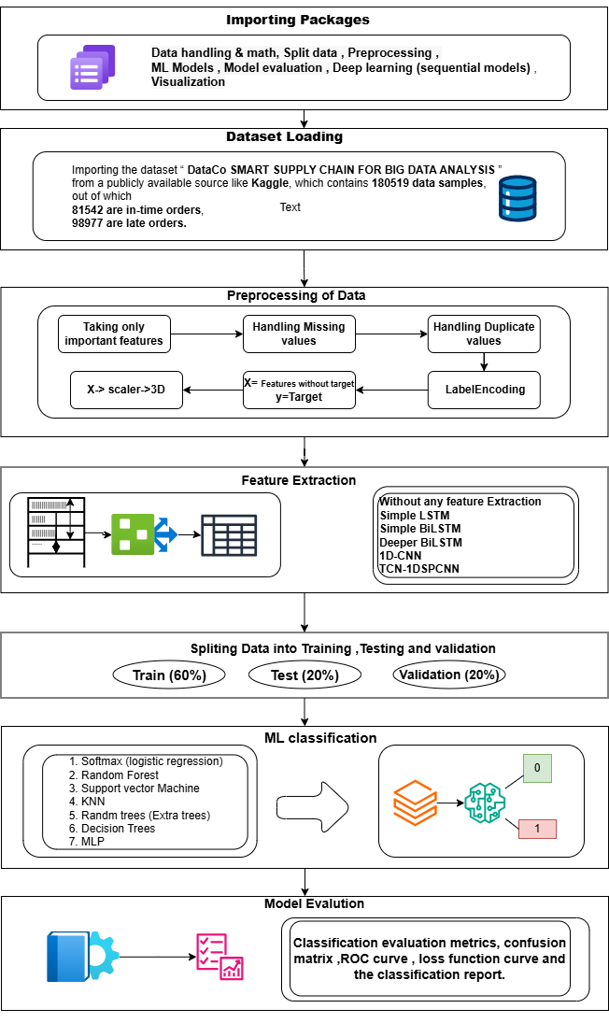
Fig : Methodology proposed

Dataset collection:-

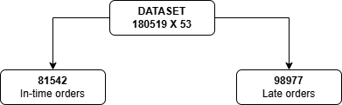
We are importing the dataset “DataCo SMART SUPPLY CHAIN FOR BIG DATA ANALYSIS ” from a publicly available source like Kaggle, which contains 180519 data samples,out of which 81542 are in-time orders and 98977 are late orders.

Fig : overview of the dataset

Loading the dataset:

Load the dataset “ DataCo SMART SUPPLY CHAIN FOR BIG DATA ANALYSIS “ by using the numpy package.In this dataset we are having special and non-ASCII characters, so we are using the encoding module.

import pandas as pd
df=pd.read_csv('DataCoSupplyChainDataset.csv',encoding='ISO-8859-1')

Preprocessing of data:-

After data loading the preprocessing will start , preprocessing inclues Data cleaning, Data Transformation, Feature engineering, Data Integration and Data Reduction
The Data Cleaning is nothing but handling Missing values, Removing duplicates entries , Correction of data types and fixing inconsistencies.
The Data Transformation is the process of scaling or Normalization ,encoding categorical variables , Log Transformations and Discretzation .
Feature Engineering involves creating new Features by using existing features ,Combining Features and Dropping Irrelevant Features.
The Data Integration is used for merging Datasets and Dealing with conflicts like resolving mismatched column names , duplicates or types.
The Data Reduction involves the steps like Dimensionality reduction and Feature selection.
After Loading the dataset“ DataCo SMART SUPPLY CHAIN FOR BIG DATA ANALYSIS ” from a publicly available source like Kaggle, The First step is to select the important features.

In this Research we have taken the two subsets of important features based on the two main criteria. The first criteria is selecting the Features that are more rellated to Order Status .And the second criteria is choosing the columns that must contribute to an increase in the performance of Machine Learining (ML) and Deep Learning (DL) Methodologies.
Based on these two most important criteria we have taken the two subsets of important features for our research. The one set contains 14 Features and the second one contains 18 features.
The first set of important features contains 180519 rows and 14 columns.

Type int32
Days for shipping (real) int64
Days for shipment (scheduled) int64
Benefit per order float64
Sales per customer float64
Late_delivery_risk int64
Latitude float64
Longitude float64
Order Item Discount float64
Order Item Discount Rate float64
Order Item Total float64
Order Profit Per Order float64
Order Status int32
Shipping Mode int32

The second set of important features contains 180519 rows and 18 columns.

Type object
Days for shipping (real) int64
Days for shipment (scheduled) int64
Benefit per order float64
Sales per customer float64
Late_delivery_risk int64
order date (DateOrders) object
Order Item Discount float64
Order Item Discount Rate float64
Order Item Product Price float64
Order Item Profit Ratio float64
Order Item Quantity int64
Sales float64
Order Item Total float64
Order Profit Per Order float64
Product Price float64
shipping date (DateOrders) object
Shipping Mode object

After selecting important features , we have performed handling missing values. First we eed to check for any missing values in our datasets is we have any we need to handle them or else it will create an impact on the model accuracy and the performance.

def features_with_missing_values(data):
x = data.isnull().sum().sum()/(data.shape[0]*data.shape[1])*100
print('Percentage of Total Missing Values is ' ,round(x,2) ,'%')
print('Missing Value Estimation :')
for i in data.columns:
if data[i].isna().sum()>0:
print('The Feature ',i,' has '+ str(data[i].isna().sum()) + ' missing values')

features_with_missing_values(df)

Finding missing values in the Dataset

After the handling of missing values we check for duplicate values in our dataset. If we have any duplicate values we need to drop them because duplicate records can give unfair weight to certain values which leades to biased results. So by handling the duplicate values ensures the quality, improves the accuracy and efficiency of the model.

df1.duplicated().sum()
df1=df1.drop_duplicates()

Handling Duplicate values in the Dataset

After handling duplicates the next step is LabelEncoding . LabelEncoding is the process of converting the categorical values into numerical form. In the dataset we are having some categorical values columns so by using LabelEncoding we we are encoding categorical values.

from sklearn.preprocessing import LabelEncoder
categorical_cols = ['Type','Order Status', 'Shipping Mode']
le = LabelEncoder()
for col in categorical_cols:
df1[col] = le.fit_transform(df1[col])

Encoding of Data

Then we are going to split the preprocessed data into X and y where X contains all columns except the target column which is Late_delivery_risk and y contains the target column.

X = df1.drop(columns=['Late_delivery_risk']) # features
y = df1['Late_delivery_risk'] # target

Data Splitting

And then X is converted into scalar and then converted into three dimensional because as we are using Deel learning models like LSTM, BiLSTM, Deeper BiLSTM , 1D-CNN ,TCN-1DSPCNN requires the input in three dimensional format.

from sklearn.preprocessing import MinMaxScaler
import numpy as np
scaler = MinMaxScaler()
X_scaled = scaler.fit_transform(X)
X_3D = X_scaled.reshape((X_scaled.shape[0], 1, X_scaled.shape[1]))

Converting data into 3 dimensional format

Feature Extracton:

By using deep Learning models like Simple LSTM , Simple BiLSTM , Deeper BiLSTM , 1D-CNN ,TCN-1DSPCNN. In this research we have experimented with various Deep Learning models for feature extraction.
The feature extraction refers to the conversion of text data into numerical format so that the models can easily understand them . Whe input data which in the text format is passed to the deep Learning models for the feature extraction theinput data will be passed through layes and finally resulta a useful and more informative data for the models to train and predict the results of the next upcoming data.
In Deep Learning the models have layered structure format where the input will be processed in all the hidden layers.
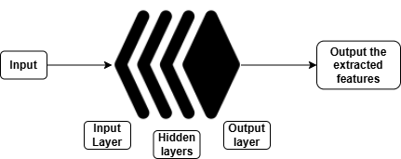

Fig : Basic structure of the Deep Learning model
for feature extraction

Simple LSTM for Feature extraction:-

Simple LSTM stands for Simple Long-Short-Time-Memory . It is a one of the type of model in the Recurrent Neural Network (RNN).This model is specially used to handle sequential data and learn long-term dependencies, employing a cell-like structure with gates to manage information flowof data. Simple LSTM is used to process the data in only one direction either right to left or letf to right.
In the present research we have used 5 layers in the Simple LSTM .
Layer 1: input sequence layer
Layer 2: LSTM layer
Layer 3: Fuly connected layer-1
Layer 4: Fully connected layer-2
Layer 5: Will be the classification layer with Machine Learning Models.

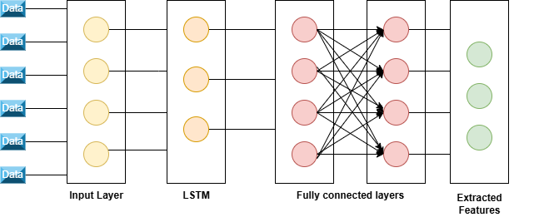
Fig : Architecture of the Simple LSTM

Simple BiLSTM for Feature extraction:-

Simple BiLSTM stands for Simple Bidirectional-Long-Short-Time-Memory . It is a other type of model in the Recurrent Neural Network (RNN).This model is specially used to handle sequential data and learn long-term dependencies in both the directionals at aime . Simple BiLSTM is used to process the data in two directions from right to left and left to right.
In the present research we have used 5 layers in the Simple BiLSTM .
Layer 1: input sequential layer
Layer 2: BiLSTM layer
Layer 3: Fuly connected layer-1
Layer 4: Fully connected layer-2
Layer 5: Will be the classification layer with Machine Learning Models.

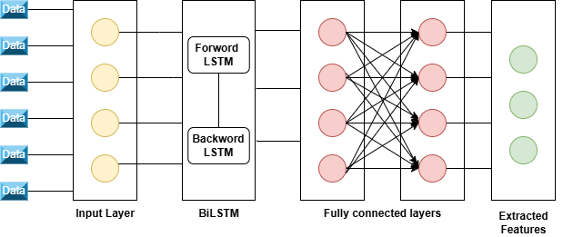

Fig : Architecture of the Simple BiLSTM

Deeper BiLSTM for Feature extraction:-

Deeper BiLSTM stands for Deeper Bidirectional-Long-Short-Time-Memory .Deper BiLSTM is the model which is a stack of the multiple BiLSTM layers which is more efficient in the feature extraction .
In the present research we have used 8 layers in Deeper BiLSTM .
Layer 1: input sequential layer
Layer 2: BiLSTM layer-1.
Layer 3: Dropout Layer-1.
Layer 4: BiLSTM layer-2.
Layer 5: Dropout Layer-2.
Layer 6: Fully connected layer-1.
Layer 7: Fully connected layer-2.
Layer 8: Will be the classification layer with Machine Learning Models.
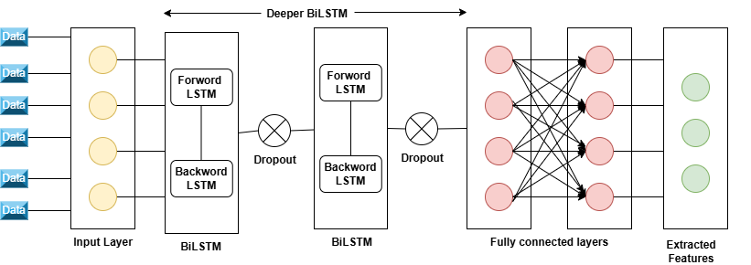
Fig : Architecture of the Deeper BiLSTM

1D-CNN for Feature extraction:-

1D-CNN stands for One-Dimensional Convolutional Neural Network. It is one type of Neural Network , it uses the convolution layes or the feature extraction from the input.
In the present research we have used 12 layers in the 1D-CNN..
Layer 1: input sequential layer
Layer 2: Conv1D layer with 32 filters.
Layer 3: ReLU
Layer 4: BatchNormalization
Layer 5: Conv1D layer with 64 filters.
Layer 6: ReLU
Layer 7: BatchNormalization
Layer 8: Conv1D layer with 96 filters.
Layer 9: ReLU
Layer 10: BatchNormalization
Layer 11: GlobalAveragePooling1D
Layer 12: Fully connected
Layer 13: Will be the classification layer with Machine Learning Models.
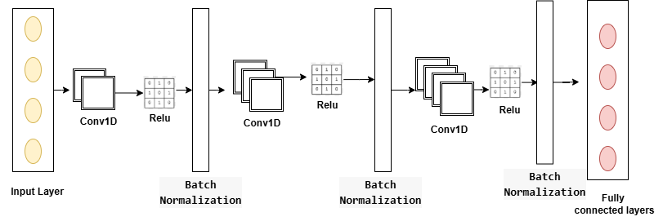

Fig : Architecture of the 1D-CNN

TCN-1DSPCNN:

The TCN stand for Temporal Convolution network is a type of 1D convolution neural network.It uses 1D convolution to anakyze temporal dependencies in the input. And it also offers parallel processing and handling variable lengths of data compared to the traditional recurrent networks like LSTM.
In this model we have used 44 layers in the 1D-CNN

Layer 1: input sequential layer
Layer 2: Conv1D layer with 32 filters.
Layer 3: BatchNormalization
Layer 4: Dropout layer
Layer 5: Conv1D layer with 32 filters.
Layer 6: BatchNormalization
Layer 7:Activation layer
Layer 8: Dropout layer
Layer 9: Conv1D layer with 32 filters.
Layer 10: Conv1D layer with 32 filters.
Layer 11: BatchNormalization
Layer 12: Dropout layer
Layer 13: Conv1D layer with 32 filters.
Layer 14: BatchNormalization
Layer 15:Activation layer
Layer 16: Dropout layer
Layer 17:Residual add
Layer 18: Conv1D layer with 32 filters.
Layer 19:Activation layer
Layer 20: BatchNormalization
Layer 21: Conv1D layer with 64 filters.
Layer 22:Activation layer
Layer 23:BatchNormalization
Layer 24: Conv1D layer with 96 filters.
Layer 25:Activation layer
Layer 26:BatchNormalization
Layer 27:Conv1D layer with 32 filters.
Layer 28:BatchNormalization
Layer 29:Activation layer
Layer 30:Dropout layer
Layer 31:Max pooling 1D layer
Layer 31:Conv1D layer with 64 filters
Layer 33:BatchNormalization.
Layer 34:Activation layer
Layer 35:Dropout layer
Layer 36:Max pooling 1D layer
Layer 37:Conv1D layer with 96 filters
Layer 38:BatchNormalization.
Layer 39:Activation layer
Layer 40:Dropout layer
Layer 41:Max pooling 1D layer
Layer 42:GlobalAveragePooling1D
Layer 43: Fully connected layer-1
Layer 44: Fully connected layer-2
Layer 45: Will be the classification layer with Machine Learning Models.

Machine Learning Classification models:-

After the feature extracion by using Deep Learning models we are going to pass the extracted features to the 7 machine learning classification algorithms for the classification purpose. The classification models wil classify that data into 2 classes , one is for Late orderas and other is for in time orders.
Models used for classification purpose:
- Softmax(Multinomial logistic regression)
- Random Forest
- Support vector classifier
- KNN
- Random Trees
- Decision Trees
- MLP (Multilayer Perceptron)

RESULTS:-

After appling feature extraction and then the classification by using different Deep Learning and machine Learning models , We have the following results.
Case-1: Without any feature extraction.In this Random trees , decision trees and random forest and MLP are showing higher accuracy.

Classification Models | INPUT SIZE | Training | Testing | Validation
SOFTMAX | 180515 X 13 | 98.304 | 98.224 | 98.254
RANDOM FOREST |  | 100.000 | 100.000 | 100.000
SVC |  | 87.620 | 87.350 | 87.280
KNN |  | 78.050 | 62.960 | 62.610
RANDOM TREES |  | 100.000 | 99.900 | 100.000
DECISION TREES |  | 100.000 | 100.000 | 100.000
MLP |  | 99.835 | 99.828 | 99.842

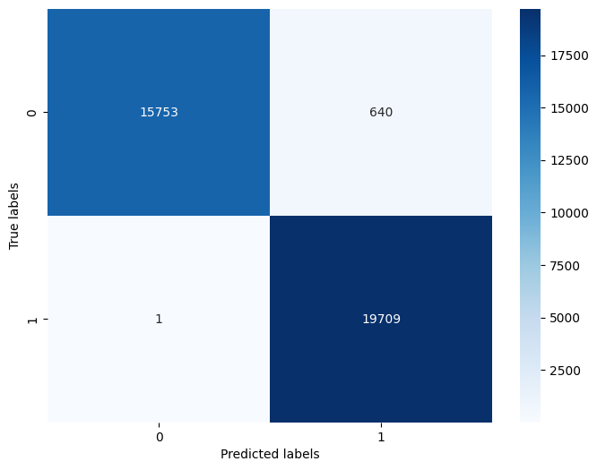

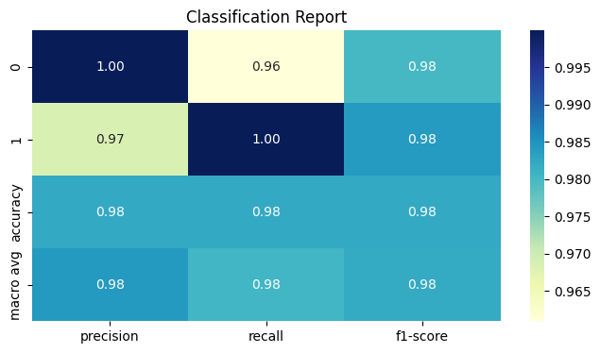
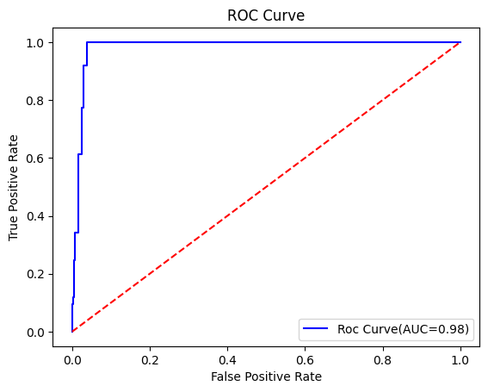

Fig : WIthout feature extraction and softmax (multinomial logistic regression)

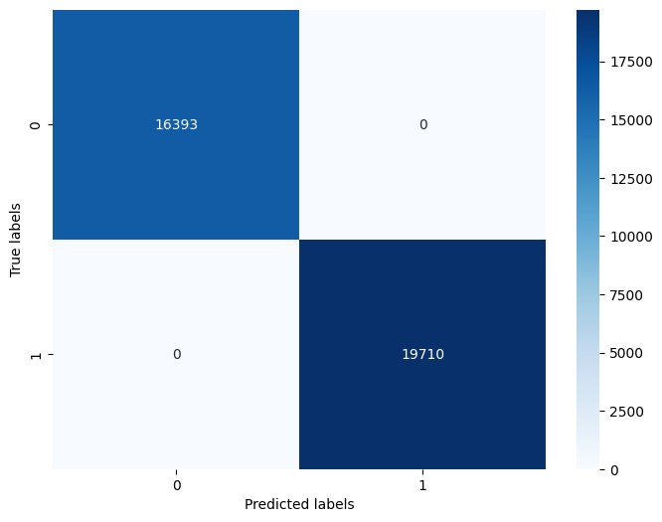

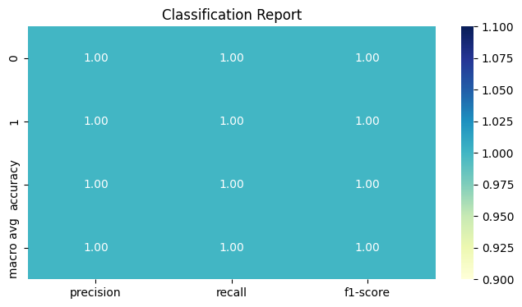
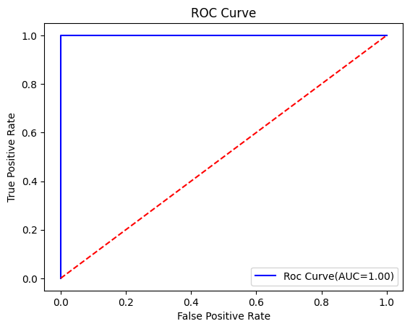
Fig : WIthout feature extraction and Random Forest

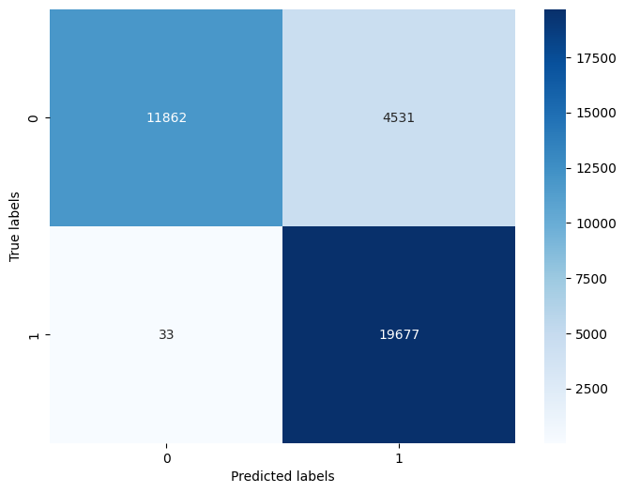
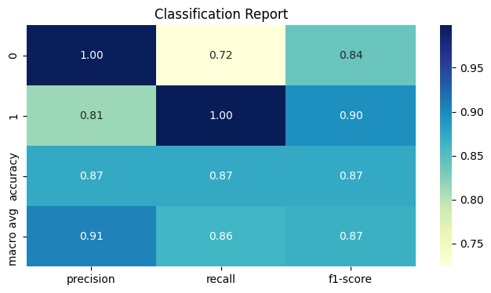
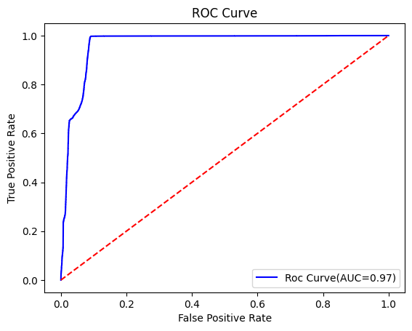
Fig : WIthout feature extraction and SVM

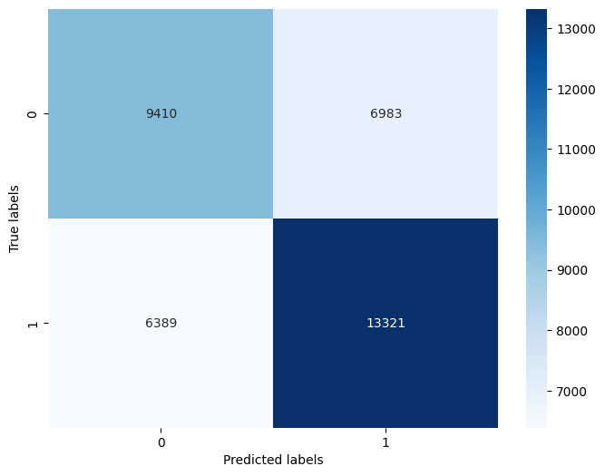
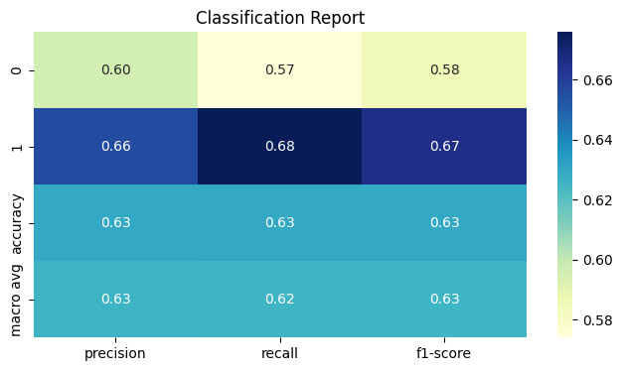
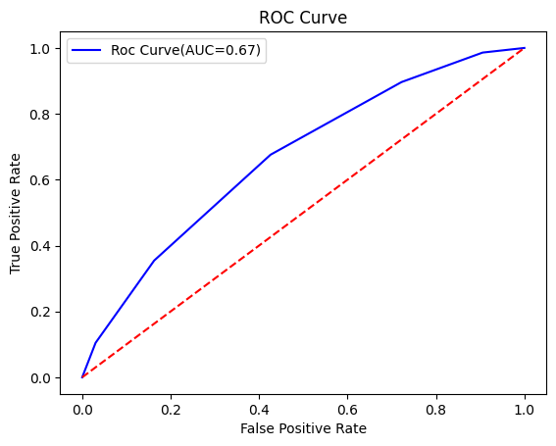
Fig : WIthout feature extraction and KNN

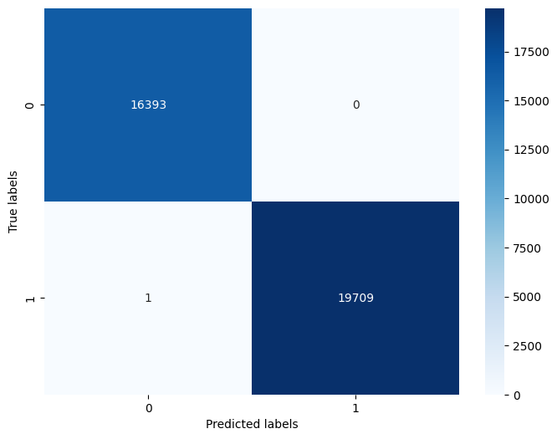
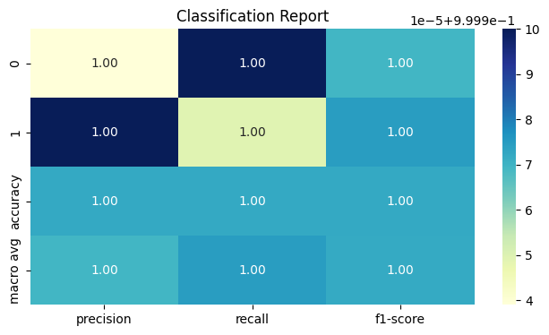

Fig : WIthout feature extraction and Random Trees





Fig : WIthout feature extraction and Decision trees

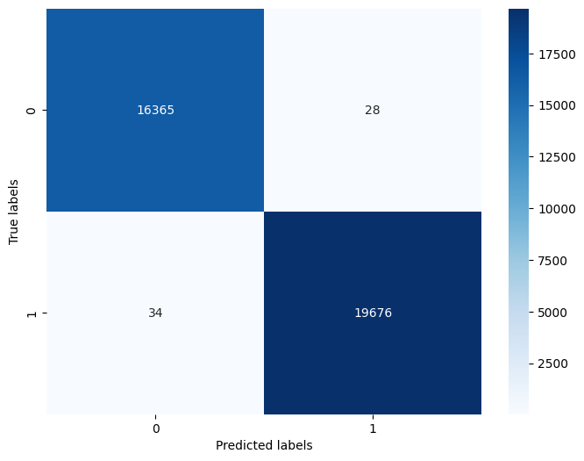
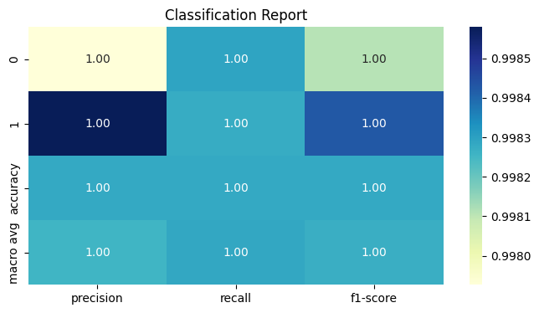
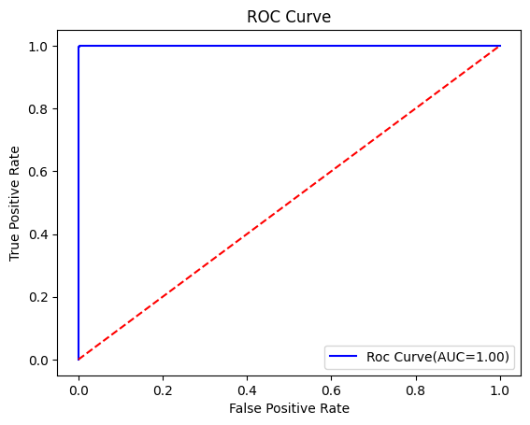
Fig : WIthout feature extraction and MLP

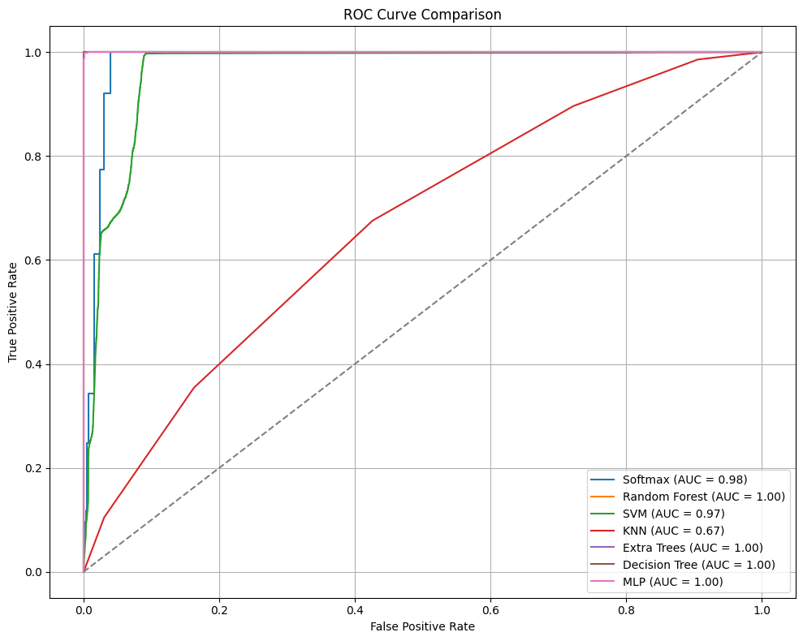
Fig : WIthout feature extraction and 7 ML models ROC Curve Comparison

Case-2: Simple LSTM feature extraction with 14 important features.In this one the tree models ,MLP , KNN ,SVC are showing higher accuracy.

Classification Models | INPUT SIZE | Training | Testing | Validation | Five-Fold cross validation
SOFTMAX | 180515 X 1 X 32 | 91.610 | 91.430 | 91.460
RANDOM FOREST |  | 100.000 | 99.700 | 99.700 | (0.9985,0.9981,0.998,0.9975,0.998) = 0.9980  99.9,100,100
SVC |  | 98.590 | 98.490 | 98.620
KNN |  | 99.700 | 99.500 | 99.500
RANDOM TREES |  | 100.000 | 99.800 | 99.800 | (0.9989,0.9987,0.9988,0.995,0.9984)=0.9987  99.94,100,100
DECISION TREES |  | 100.000 | 98.770 | 98.900 | (0.9907,0.9904,0.9913,0.9917,0.9919)=0.9912  99.7,100,100
MLP |  | 99.880 | 99.830 | 99.850

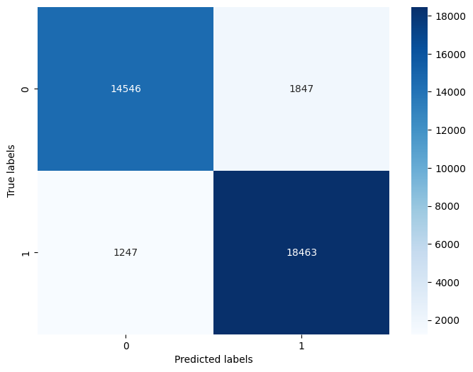
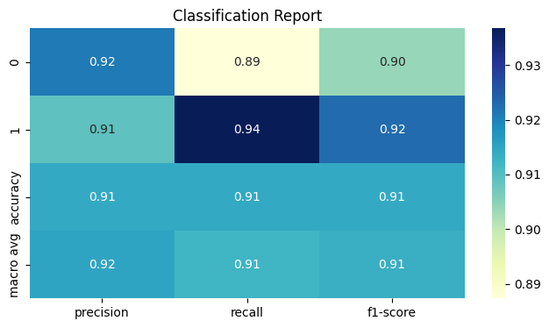
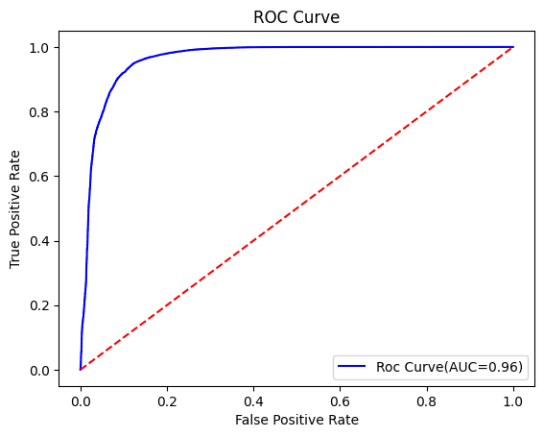
Fig: Simple LSTM and Softmax

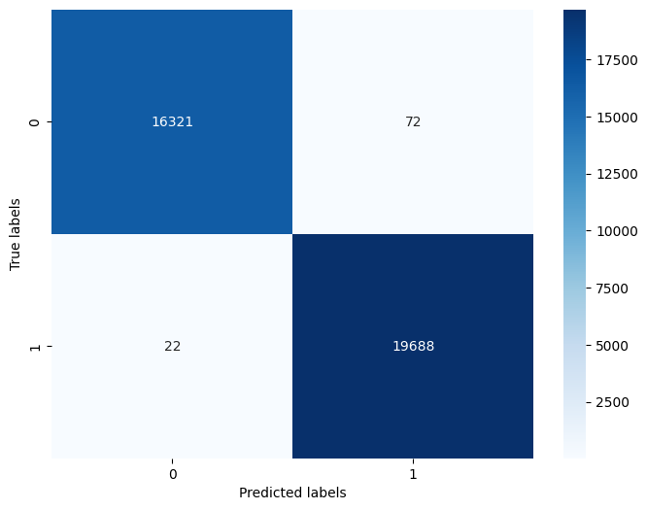

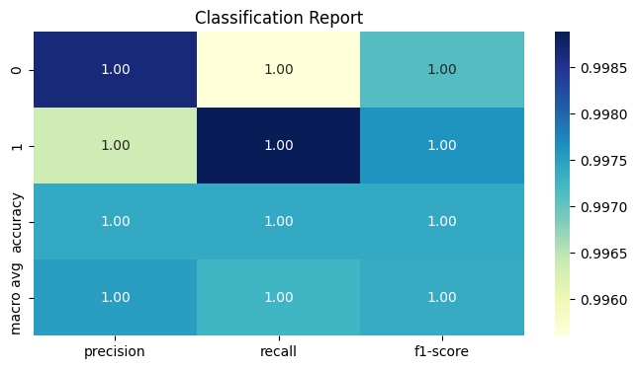
Fig : Simple LSTM and Random Forest

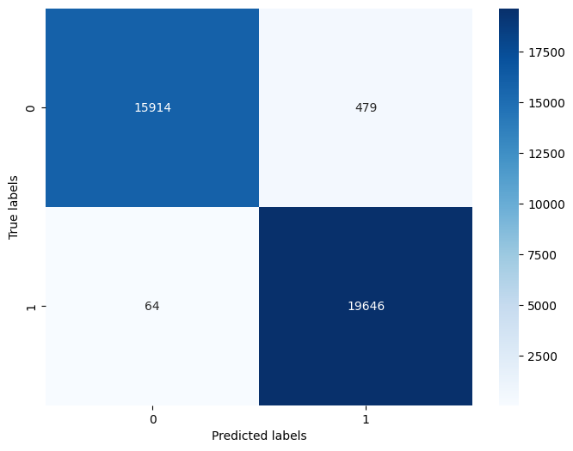
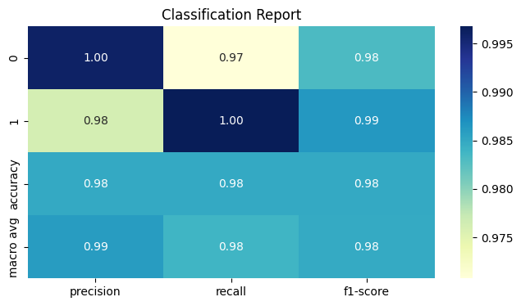
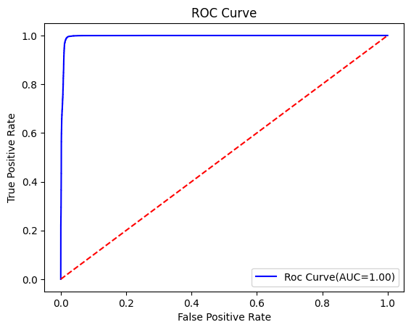
Fig : Simple LSTM and SVM

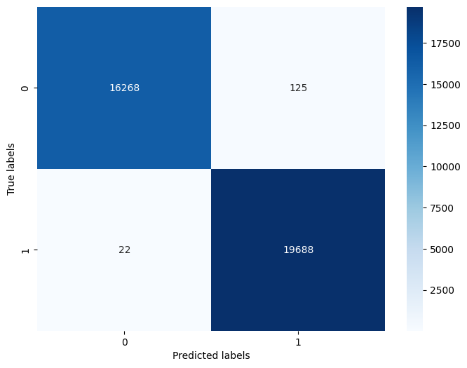

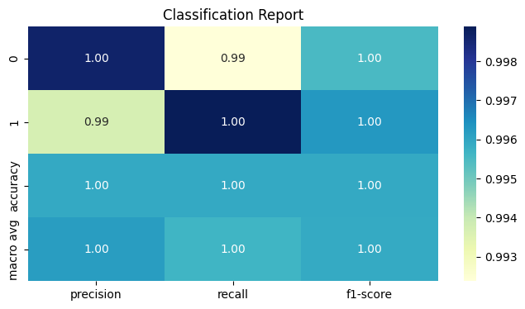

Fig : Simple LSTM and KNN

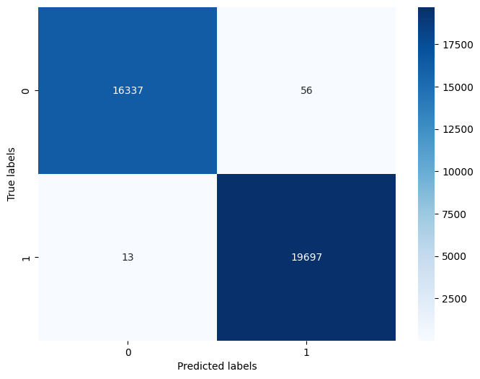

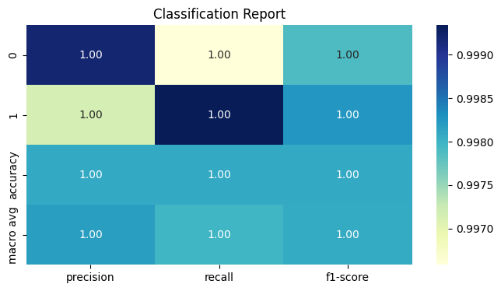

Fig : Simple LSTM and Random Trees

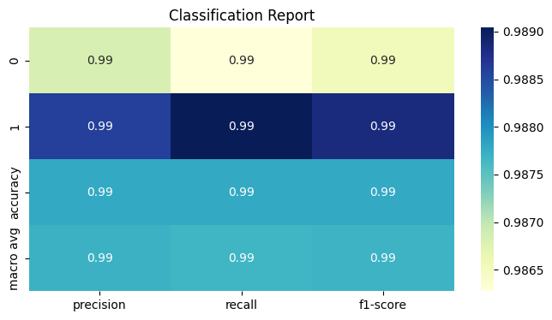
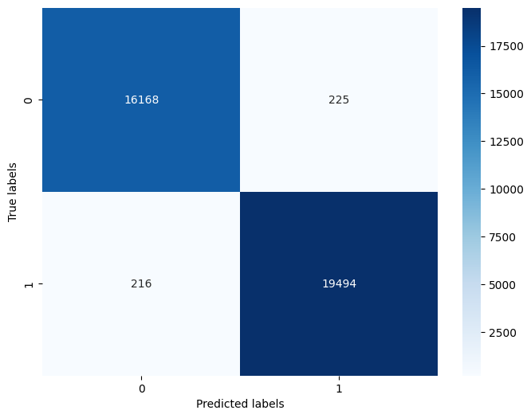

Fig: Simple LSTM and Decision Trees

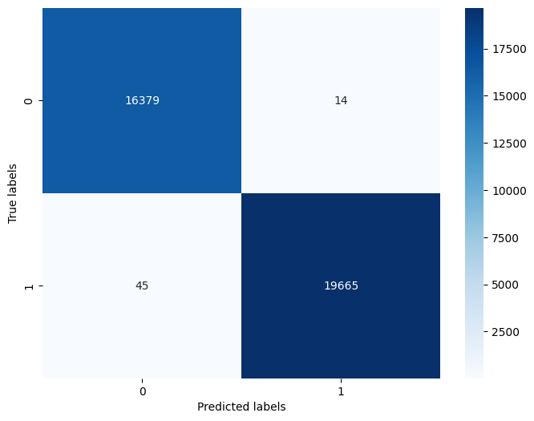
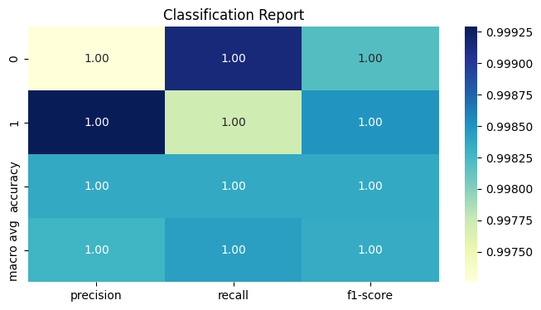
Fig : Simple LSTM and MLP

Case 3: Simple BiLSTM feature extraction and 7 machine learning classifiers. This approach the tree models, MLP, KNN,SVC are high in their performance.

Classification Models | INPUT SIZE | Training | Testing | Validation | Five-Fold cross validation
SOFTMAX | 180515 X 1 X 32 | 91.920 | 91.770 | 91.490
RANDOM FOREST |  | 100.000 | 99.850 | 99.870 | (0.9989,0.9991,0.9991,0.9988,0.9991)=0.9990  99.9,100,100
SVC |  | 99.390 | 99.310 | 99.310
KNN |  | 99.920 | 99.860 | 99.860
RANDOM TREES |  | 100.000 | 99.910 | 99.910 | (0.9991,0.9994,0.9994,0.9991,0.9993)=0.9993  99.9,100,100
DECISION TREES |  | 100.000 | 99.000 | 99.030 | (0.9925,0.9919,0.9918,0.9912,0.9925)=0.9920  99.7,100,100
MLP |  | 99.860 | 99.830 | 99.810

Case 4: Deeper BiLSTM. With this approach which is Deeper BiLSTM with 7 ML models the tree models,KNN,SVC, MLP are showing hih accuracy.

Classification Models | INPUT SIZE | Training | Testing | Validation | Five-Fold cross validation
SOFTMAX | 18051 X 32 | 82.360 | 82.130 | 82.200
RANDOM FOREST |  | 100.000 | 99.700 | 99.600 | (0.998,0.997,0.998,0.9979,0.9979)=0.9980  99.9,100,100
SVC |  | 98.620 | 98.490 | 98.600
KNN |  | 99.770 | 99.580 | 99.600
RANDOM TREES |  | 100.000 | 99.800 | 99.700 | (0.9987,0.9984,0.9988,0.9983,0.9983)=0.9985  99.94,100,100
DECISION TREES |  | 100.000 | 98.780 | 98.750 | (0.99,0.9907,0.9910,0.990,0.9905)=0.9904  99.68,100,100
MLP |  | 97.950 | 97.790 | 97.830

Case 5: 1D-CNN as Feature extraction with machine Learning models.The tree models, MLP,KNN,SVC are having higher accuracy and performance.
Classification Models | INPUT SIZE | Training | Testing | Validation | Five-Fold cross validation
SOFTMAX | 180515 X 128 | 89.230 | 89.120 | 89.310
RANDOM FOREST |  | 100.000 | 99.800 | 99.800 | (0.999,0.9993,0.9991,0.9989,0.9989)=0.9998  99.96,100,100
SVC |  | 98.640 | 98.580 | 98.640
KNN |  | 99.830 | 99.680 | 99.680
RANDOM TREES |  | 100.000 | 99.920 | 99.880 | (0.9994,0.9991,0.9993,0.9989,0.9992)=0.9992  99.97,100,100
DECISION TREES |  | 100.000 | 99.130 | 99.110 | (0.9925,0.9930,0.9925,0.9925,0.9923)=0.9926  99.7,100,100
MLP |  | 99.980 | 99.980 | 99.970

Case 6: TCN-1DSPCNN as the feature extraction. Here the tree models, KNN, MLP are having better accuracy.

Classification Models | INPUT SIZE | Training | Testing | Validation | Five-Fold cross validation
SOFTMAX | 180515 X 32 | 67.900 | 67.810 | 68.060
RANDOM FOREST |  | 100.000 | 98.710 | 98.720 | (0.9889,9901,0,9910,0,9902,0.9896)=0.9900  99.6,100,100
SVC |  | 93.370 | 93.380 | 93.270
KNN |  | 99.290 | 98.790 | 98.840
RANDOM TREES |  | 100.000 | 99.070 | 99.060 | (0.9921,0.9926,0.9936,0.9920,0.9920)=0.9925  99.73,100,100
DECISION TREES |  | 100.000 | 96.330 | 96.330 | 90.9658,0.9680,0.9692,0.9691,0.9685)=0.9681  98.95,100,100
MLP |  | 96.330 | 96.130 | 96.060

Case 7 : Simple LSTM with softmax layer as the the classifier with 14 important features

Classification Models | INPUT SIZE | Training | Testing
SOFTMAX Layer | 180515 X 64 | 99.400 | 99.450

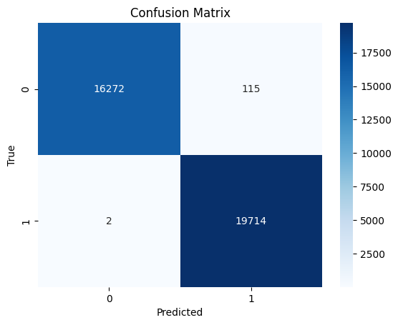
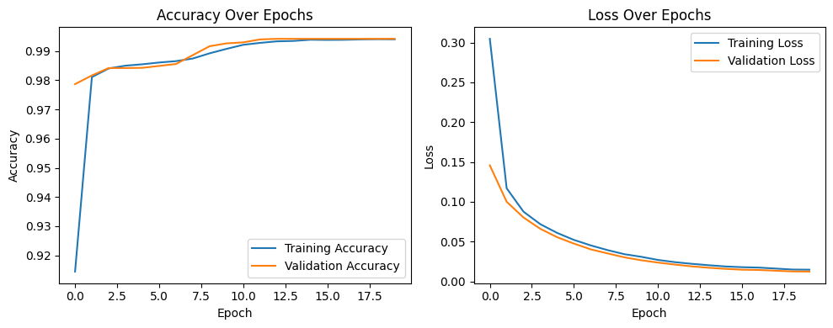
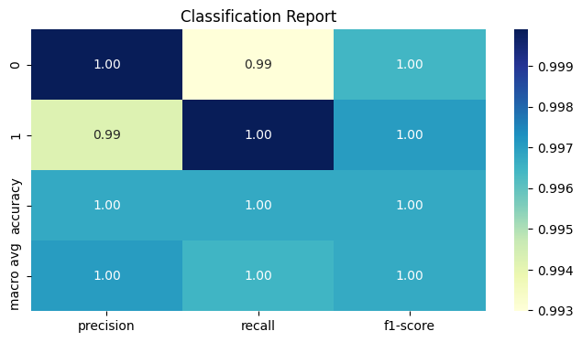

Fig : Simple LSTM with softmax Layer as the classifier with 14 features

Case 8: Simple LSTM with softmax layer as the classifier with 18 Features.

Classification Models | INPUT SIZE | Training | Testing
SOFTMAX Layer | 180515 X 32 | 97.490 | 97.570

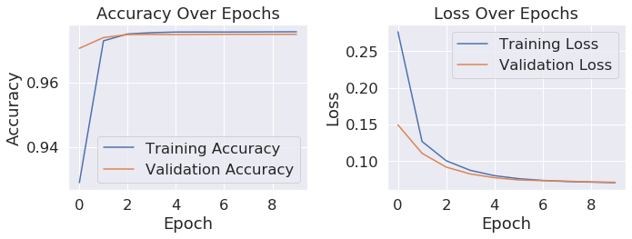
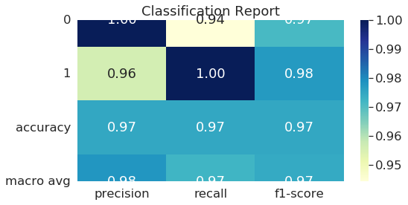

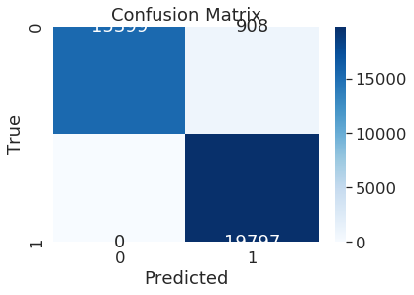

Fig : Simple LSTM with softmax layer as the classifier with 18 features

Over all the experiments the tree models are showing 100% accuracy where it may be a chance for overftting also but we have checked it with the five fold cross validation also where the accuracy remains same.Then MLP are working in may cases and then KNN and SVC are also giving better accuracy .And the Simple LSTM wih 14 features and softmax layer as the classifier is showing the beter accuracy in training and testing.

Five Fold cross validation:

The Five-Fold cross validation is a resampling method used in the Machine Learning Models to assess performance of the model. In then the whole data is divided into 5 equal parts and then 4 parts are used for training andthe remaining part is used for testing / validation and this cycle is repeated for 5 times . By using this we can check whether the model is overfitted or not.

References:

Dataset:- DataCo SMART SUPPLY CHAIN FOR BIG DATA ANALYSIS.
Link:-https://www.kaggle.com/datasets/shashwatwork/dataco-smart-supply-chain-for-big-data-analysis
Shape:- 180519 X 53

Base Paper:-Deep learning approaches to identify order status in a complex supply chain.
Link:- https://www.sciencedirect.com/science/article/pii/S0957417424008133

Preprocessing the data:
Link-1: https://www.kaggle.com/code/shbose/e-commerce-project

Link-2:https://www.kaggle.com/code/farreldr/prediksi-resiko-late-delivery-dataco-supply-chain

Link-3:https://www.kaggle.com/code/adityabatsexemplary/supply-chain

